

SIMATS ENGINEERING

Saveetha Institute of Medical and Technical Sciences Chennai- 602105
Student Name:Sahana.F Reg. No.:192320031
Course Code:CSA-0208 Slot:D
Course Name:C - programming
Course Faculty:Dr.Jayasudha

Project Title:The last floor an adaptive 3D psychological horror and escape game
Module Photographs: (3 photographs –Module Photo, Individual student contribution module work in the project and presentation image)
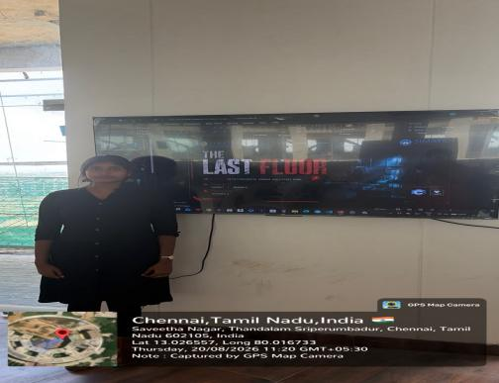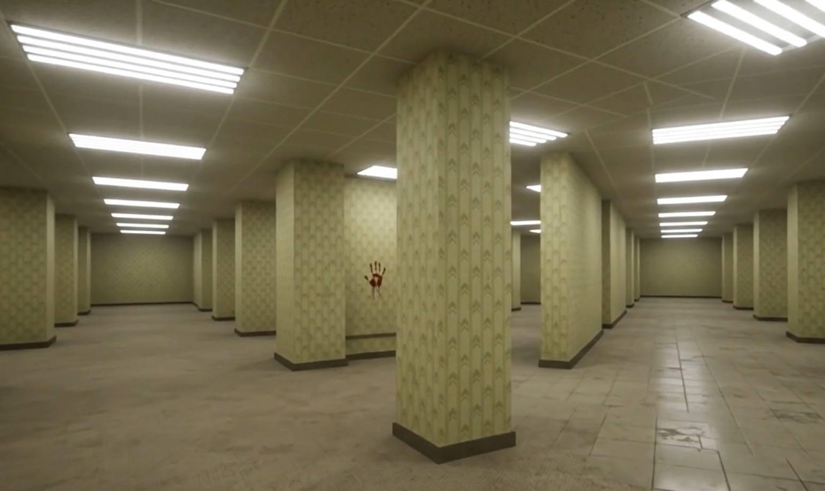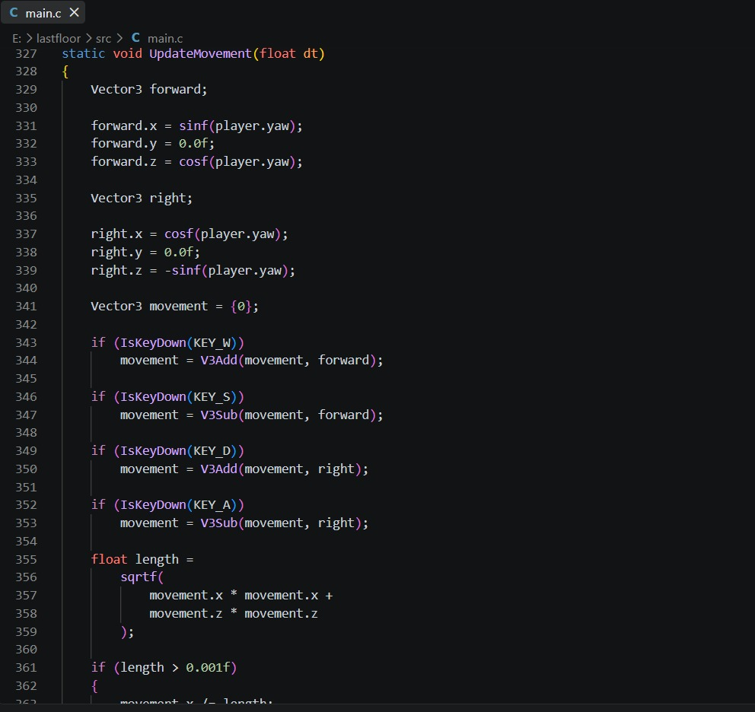
Fig 2:Module Photo
Fig 3:Individual student contribution
Fig 1: presentation image
Project Description: Module Description: Module 2 adds gameplay and adaptive systems, enabling enemy behaviour and game events to change based on player actions for a dynamic and replayable horror experience.
THE LAST FLOOR – Module 2 focuses on developing the gameplay systems and adaptive engine that make the horror experience dynamic and interactive. It builds on the core engine by introducing inventory management, puzzles, enemy AI, behaviour tracking, save/load functionality, and game progression.The adaptive engine allows enemies to patrol, search, and chase the player based on their actions and surroundings. Game events, item locations, and enemy behaviour can change between sessions, making each gameplay experience less predictable.Overall, this module creates a dynamic and replayable horror experience, where player decisions influence enemy encounters and game events, ensuring that each playthrough can feel different and challenging.

Student Signature Guide Signature

